**Report from 2016 IEA-RA**

**Submitted by Mike Dusik and Stella Styrczula**

My first selfie!

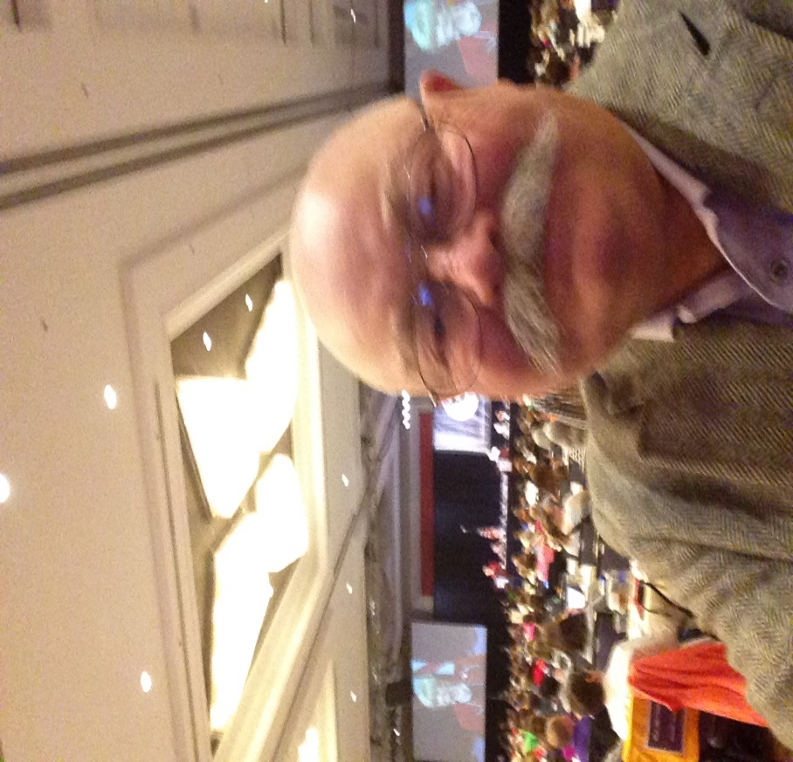

This year’s Convention did not deal with a budgetbecause we now do budgeting over two years. Therefore, the major business item was the reformation of the state governance by the IEA Board. The amendment would have reduced the governing board from approximately 90 members to one consisting of 13 members. The thought was that this would create a nimbler board that could react to events in a timely manner. It would also have been a less expensive board operationally.

There was a great deal of resistance to this initiative from downstate and all the smaller locals. This amendment appeared to be some sort of veiled power grab by the Northeast powers in our state from the viewpoint of our southern and western locals. This ended in a very unusual closed door individual written and signed ballot vote because the verbal vote was too close to call. This vote led to the defeat of the amendment.

Action Requested on support of the Plainfield School District Custodial Staff. They are in danger of having their jobs privatized.

Action Requested on Springfield Rally on the 20th of April. We are asking everyone to attend, friends, family, students, anyone interested in supporting funding for higher education in Illinois. Transportation can be arranged by the IEA. If we provide the participants, they will get them there.

As you can see from the rest of the report we covered a lot of territory. If there is any specific area that you are interested in, please contact Stella or myself and we will provide whatever information and insights that we acquired.

The culminating activities on Saturday included two excellent presentations that I personally found both informative and entertaining. The first was by Dr. Jim Sporieder former Principal of Lincoln High School that *Paper Tigers* was based upon. The last presentation was by Donna Brazile who was both informative and entertaining.

Stella and I worked with the CODFA representatives Jackie McGrath, Region 32 Chair and therefore on the IEA Board of Directors, Richard Jarman, CODFA VP, and Eric Thompson Criminal Justice Professor. We emphasized union solidarity and I believe we made some progress in breaking barriers between our groups.

Overall impressions of this RA was that it was productive and our members demonstrated that democracy can be messy, but it is still the best and fairest method of governance. Every member who had something to say was able to make their case, and all decisions were made by the delegates of our total membership. There were approximately 1300 representatives present. However, there was no press representation this year. Both Stella and I did our best to represent your views and interests at the RA. I think I can speak for all of us when I say that I am proud to be associated with the IEA. It is an organization that really does have a positive impact on the education of all of our states students.

Officers, thanks for all you do. Mike and Stella

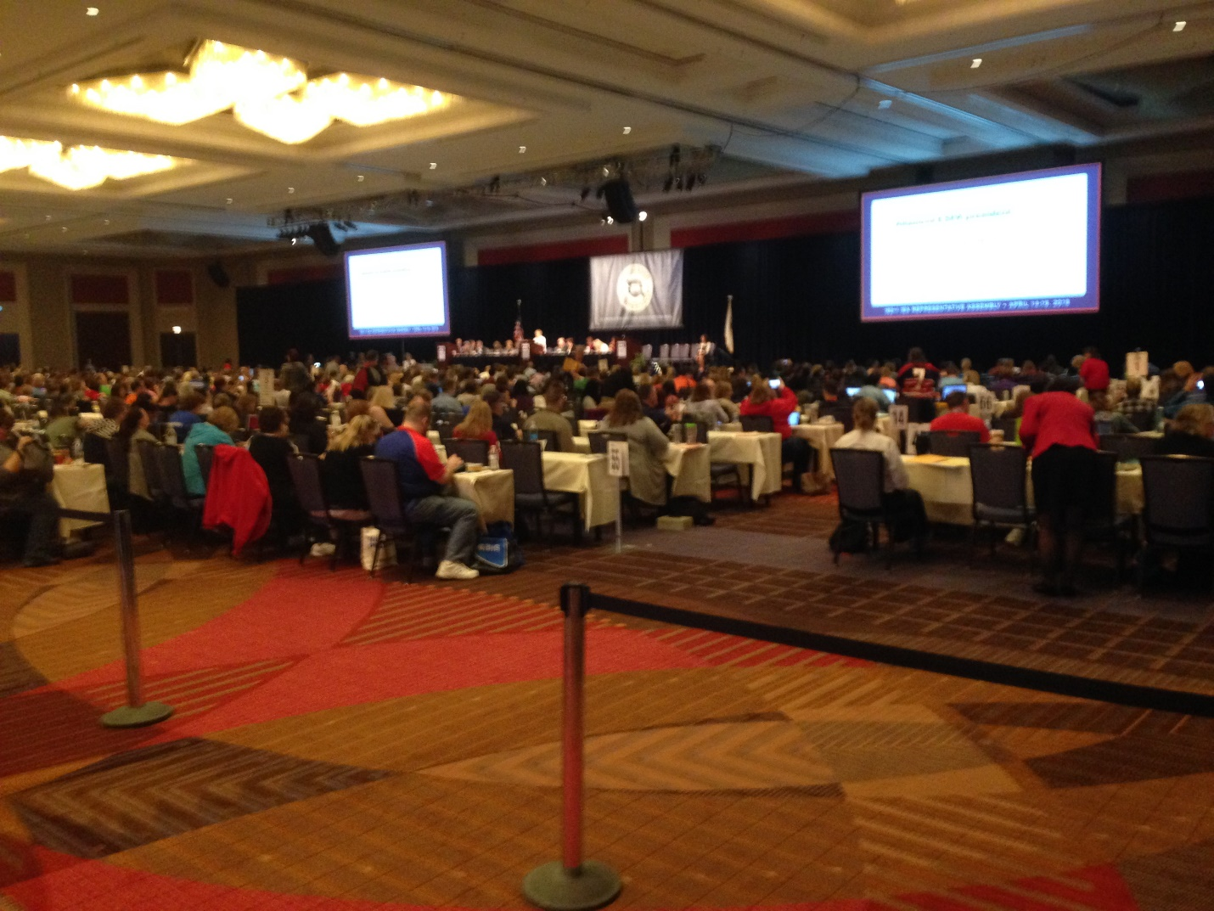

**Report from 2016 IEA-RA**

**New Business (Action Items)**

* In jobs section on IEA website, show which are districts affiliated with IEA--
* Discourage IEA travel to states that have anti-LGBT legislation--
* Develop a plan to expand ESPs ability to qualify for FMLA--
* Create educational materials regarding the effects of racists stereotypes and mascots on students--
* Provide information to members about WEP/GPO--
* Integrate in member training, information on institutional racism in our country-
* Suggest districts to support LGBTQ students in accordance with “Schools in Transition” recommendations--

**Legislative Amendments (Documents that guide our lobbyists)**

The association:

* Opposes the use of student assessments in educator performance evaluations.
* Supports legislation that school libraries shall be staffed by a state licensed librarian with appropriate endorsements.
* Supports legislation that reflects appropriate school nurse caseloads as established by Healthy People 2020 and the National Association of School Nurses.
* Supports Performance Funding programs only when the state maintains sufficient funding.
* Opposes the use of subcontracted digital learning techniques for the provision of special ed and related services.
* Supports ESPs eligibility for FMLA.
* Supports that the responsibility for evaluation of Illinois teacher candidates rest with the accredited college/university. (against EdTPA)
* Supports the establishment of a state or community bank similar to The Bank of North Dakota.

**Bylaw Amendments**

* Restructure the IEA governance--**Did not pass**
* Board of Directors can choose to prorate dues--Passed
* Allow ESPs to maintain membership, even if employment does not--Passed
* Caps region funds--Did not pass
* Allows a later date to submit a bylaw amendment--Passed

**Professional Development**

* Student Learning Objectives (SLOs)
  + A joint committee must now be in place in the district.
  + Template is available on IEA website in the Members Only section
  + Some groups are exempt (School Counselors, Psychologists, etc.)
  + Your committee may CHOOSE to add other exemptions
  + Minimum of 30% beginning in the 3rd year of implementation

**TRS Pension Updates (*NOTE ALL THE Illinois Pension systems are underfunded)**

* 2015 Updates
  + Revenue (earnings and contributions)= $6.2 billion
  + Benefits paid = $5.5 billion
  + Average Pension $52,752
  + Total Portfolio $46.1 billion (4.0% return)
* TRS focuses on long-term results and, due to the large size of funds, attracts the best financial advisors
* Issues facing TRS and Pension system
  + ERO will expire on 7/1/2016 unless it is extended (we expect it to expire)
  + Budget--TRS payment for November has not yet been made
  + Buyout Proposals
    - Due to the lack of funding, we couldn’t afford to continue paying retirees if everybody decided to do that
  + A private firm will work to implement Health Insurance
* Some notes from Cinda
  + TRS is a DEFINED BENEFIT program
  + Tier II members pay more than they should and will possibly be forced in S.S.
  + Access your information on the TRS Secure Member Website (http://trs.illinois.gov)

**Legislative Update**

* State Budget
  + K-12 funding exists
    - $36 million funds in K-12 education have been redirected due to budget standoff (ie: teacher and administrator mentoring)
  + Higher Education funding has been eliminated
    - Asked to reduce costs by 30% by Rauner
    - Possibly costs them accreditation
    - MAP grants funding was vetoed by Rauner (MAP grants give funds to 125,000 low-income students)
    - Some layoffs for every employee at the schools
  + Standoff in attempt to reduce power of unions
* Education-related legislation
  + SB 231 (IEA neutral): Restructures state aid
  + SB 2144 (IEA opposes): A four-year university can serve as the authorizer of charter schools
  + SB 2440 (IEA opposes): Addresses school principal endorsements
  + HB 825 (IEA opposes): Round Lake school district requests to reduce  PE requirements to 2x/week
  + HB 4427 (IEA neutral): Extends the instructional time by 5 school days by replacing institute days; subject to appropriation of funds
  + HB 4592 (IEA supports): Starting 2022-23 school year, no waivers would be permitted for PE
  + SB 2912 (IEA supports): Addresses sub shortage
    - The portion of the bill (requires only 60 hours of college coursework to sub) which IEA opposes has been moved to a separate bill.
  + SB 3304 (IEA opposes): Allows a licensed professional (ie: physician)  to teach a class instead of a certified teacher.
  + HB 6144 (IEA opposes): With 50% of parent signatures, parents can control what happens in a district
  + HB 6164 (IEA opposes): Allows a district to participate in 3rd party subcontracting for driver’s ed. and PE; also includes a waiver for PE
  + HB 6299 (IEA supports): Maintains ESP seniority
  + HB 6142 (IEA opposes): LIfts the cap on charter schools
  + HB 5918 (IEA opposes): Allows charter schools to be renewed for 10 years at a time (currently the time frame is 5 years)
    - Call 1-888-209-5655 to speak with your legislator and oppose HB 5918.
* Pension
  + HR 187 (IEA supports):  States that the cost shift of the pension shift is wrong
  + HB 2247 (IEA opposes): Presents pension holders with a 75% present value and relieves state of 100% of liability
  + HB 5625 (IEA opposes): Includes a buyout of pensions
* Constitutional Amendments
  + SJRCA 1 (IEA supports): Fair tax which graduates the income tax
  + HJRCA 26 (IEA supports): Imposes a 3% surcharge on income above $3 million and the funds are appropriated to students
  + HJRCA 57 (IEA supports): This ensures that the state is the predominant funder (greater than 50%) for education.

**Every Student Succeeds Act (ESSA) Update**

* This replaced NCLB

**Union Battles Happening in Illinois**

* Plainfield Custodians
  + Trying to contract them out to a “for profit” organization
  + There is a flyer for people who live in that area
  + Facebook:  Support Our Plainfield Custodians and Rally for Plainfield Support Staff
* Altamont ESPA
  + Fighting for small pay increases and the district is offering $.05 and hour (That is less than $2 per week for most employees.)
  + Likely going on strike---Cinda will tell us when.
  + To send support:  contact President Charlene Calhoun, ℅ IEA-NEA, 104 Greenview, Effingham, IL 62401-3048;  [charlenecalhoun@frontier.com](mailto:charlenecalhoun@frontier.com)

**Calendar Info**

* Rally in Springfield
  + April 20th
  + Focused on higher education, but all are welcome
  + Can use local pack funds to provide transportation, etc.
  + If enough people want to attend, a bus can be arranged by the Region Chair or Uni-Serve Director
  + <http://www.ieanea.org/2016/04/08/statehouse-rally-to-save-higher-education/>
* Local Leadership Kickoff
  + August 2 and tentatively held at the NIU Naperville Conference Center
  + Anybody leader in the local association (including building reps) is invited
  + There are sessions specifically geared to help officers that you can choose to attend
  + For more info:  <http://www.ieanaperville.org/events/local-leadership-kickoff/>
* General Election in November
  + Attend IEA Recommendation Meetings (June-August)
  + Support IEA Recommended candidates
  + Volunteer to be a member of a GO team
  + Early voting begins Oct. 12th
  + Encourage someone else to vote
* 2016 IEA Spring Elections
  + Online ballots
  + You should have received in the mail your Election Code and Voting Pin
  + Vote by 4/27/16
  + [www.ieanea.org](http://www.ieanea.org/) (Click on “Vote now in spring statewide elections”.)
  + <http://www.ieanea.org/2016/04/11/vote-now-in-spring-statewide-elections/>
  + Questions:  Contact Kim Trader 217-321-2250
* Region Council cancelled for 4/28  (<https://region3250.wordpress.com/>)
* Summer Leadership Academy
  + Changes for this summer
  + <http://www.ieanea.org/events/summer-leadership-academy-2016/>
  + Watch email for info

**Trauma Informed School Resources**

* <http://www.ieanea.org/resources/partnership-for-resiliency/>
* Upcoming conferences
  + June 14--Elgin
  + June 15--Governor’s State University
  + June 16--Springfield
* Screening of Paper Tigers in your district
  + Contact Region Chair or Uni-Serve director about this
* Positive Parenting Program (PPP)
  + A program that the IEA is examining to help in this area