**Report on the 2016 NEA Annual Meeting,**

**Washington D.C. June27- July 7**

Submitted by Mike Dusik and Stella Styrczula

This is the NEA Washington Headquarters Building. We attended the Illinois Caucus Night held at this location. As you can see the NEA endorsed Hillary for the Presidency of the USA.

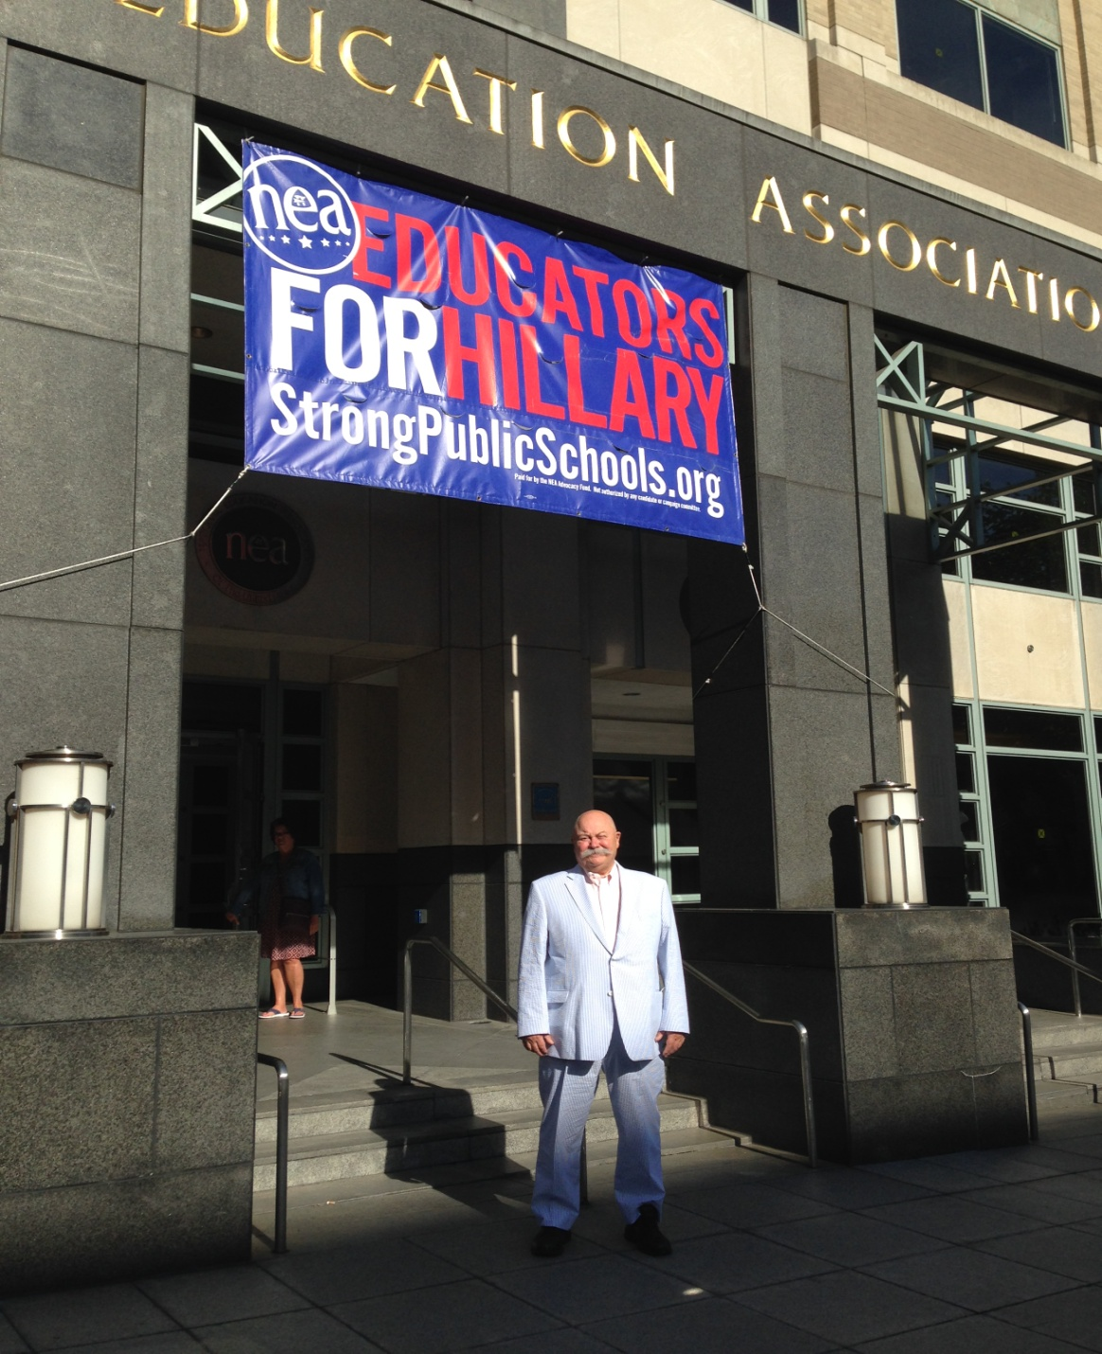

However there was a very taxing agenda to be dealt with. This is a view of the Convention floor during Hillary's address to the delegates. She promised to enact or support everything we (the NEA) desired.

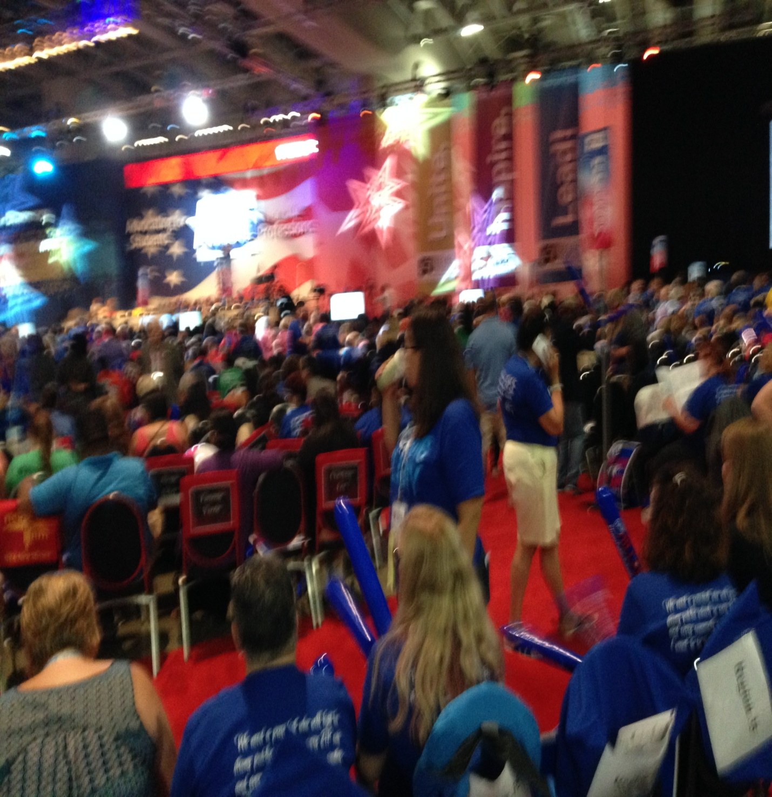

### As we began our business after the speech we were tasked with considering and voting on 10 Standing Rule Amendments and 125 Legislative Amendments. This was set up for 90 minute sessions interspaced with awards, recognitions, elections, and all the other business of the convention. Go to <http://ra.nea.org> for all details and further information on the Legislative Amendments and everything not covered in this report.

### And so our work commenced.

### C:\Users\Mike\Pictures\2016-07\IMG_0226.JPG

### As you are aware the IEA has a membership of 133,000. The NEA is not just the largest union in America; it is the LARGEST UNION IN THE WORLD. Therefore it encompasses many different groups and subsets who have varied agendas based on their unique issues. Nowhere is this truer than in the contingent faculty of which we are a part. Therefore we concentrated on the caucus that represented us. This turned out to be the Contingent Faculty Caucus.

### We identified 3 New Business items that we wanted to have passed by the assembly at our first meeting held on July 3d. Mark Smith who is the NEA Senior Policy Analyst Spoke to the unemployment compensation issue and believes we are making some progress with it. As you know this is a perennial problem for us and we have been lobbying congress for years regarding this issue. We will see if this time we have enough support to change the policy.

### The other significant speaker was Maria Maisto, founder and leader of the New Faculty Majority. If you are not aware of her work and this contingent faculty association I strongly suggest you investigate them. I was very impressed that she was at our caucus. She gave us an overview of her groups work. Because of our similar goals the NFM is increasing its contact with the NEA. Maria informed us that the GAO (Government Accounting Office) is doing a study on the working conditions of contingent faculty.

### Maria Maisto speaking at the caucus.

### C:\Users\Mike\Pictures\2016-07\IMG_0220.JPG

### C:\Users\Mike\Pictures\2016-07\IMG_0256.JPG

My name is Chris Cruz-Boone and I am a contingent faculty member from California.  This is my first RA & I am honored that today you elected me the secretary for the CFC.  In all my attempts to help improve communication have not been without fault and I know many folks have been misdirected or lost by room and time changes.

Several folks at our meetings forgot to sign in so please pass this email along to anyone at the NEA that is interested in getting involved in the CFC & might not be part of our contact list.

**DIGITAL MINUTES**

Here are direct link to our minutes from our last 2 meetings:

CFC Minutes Sun. June 3rd <https://docs.google.com/document/d/1yoFaa2in1zG1Zz88LKqyYROF8UWc6uP8A7HfKMbii_k/edit?usp=sharing>

CFC Minutes Wed. June 6th <https://drive.google.com/file/d/0B58HKh5nYwtBeUVwSDE0MUVYcWc/view?usp=sharing>

**LEGISLATIVE AMENDMENTS & ELECTIONS**  
I am so elated to report that both our legislative amendments 13 & 14 passed.  There was some resistance on the floor, and most of higher education was still in NCHE when the vote took place, but our chairperson got the vote done.

Thank you to Judy Olson and Loretta Ragsdale for getting these amendments introduced and passed.

We are now represented by newly elected contingent faculty member Loretta Ragsdale, congrats!!!!

We still need to get NBI 81 passed so please continue to spread the word.

### [Legislative Amendment 13](http://ra.nea.org/business-item/2016-lga-013/)

**Adopted As Modified**

Section: Postsecondary Education

Page 14 line 37  
Add new item  
NEA supports

– “consistent definitions of higher education part-time and contingent faculty work to ensure equality and consistency of protections under the law;”

– “resumption of and adequate funding for the National Study of Postsecondary Faculty and inclusion of data collection on both tenure-line and contingent faculty;”

– “a more comprehensive work supplement from the Bureau of Labor Statistics that would include contingent academic workers and would be conducted at regular intervals beyond the 2017 update.”

[**Legislative Amendment 14**](http://ra.nea.org/business-item/2016-lga-014/)

**Adopted**

Section: Postsecondary Education

Page 14 line 37  
Add new item  
NEA supports

“transparency about higher education faculty working conditions in order to prompt colleges and universities to accurately disclose to the public the working conditions of all of its faculty and professional staff, including numbers, compensation, and access to institutional support of part-time contingent faculty.”

Convention Art (Democrats and Republicans?)

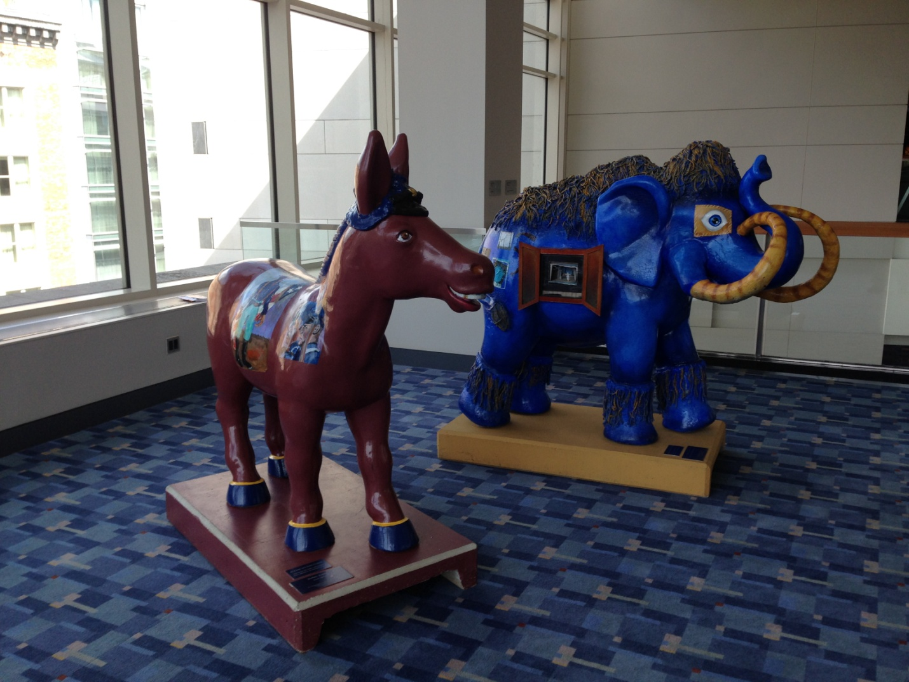

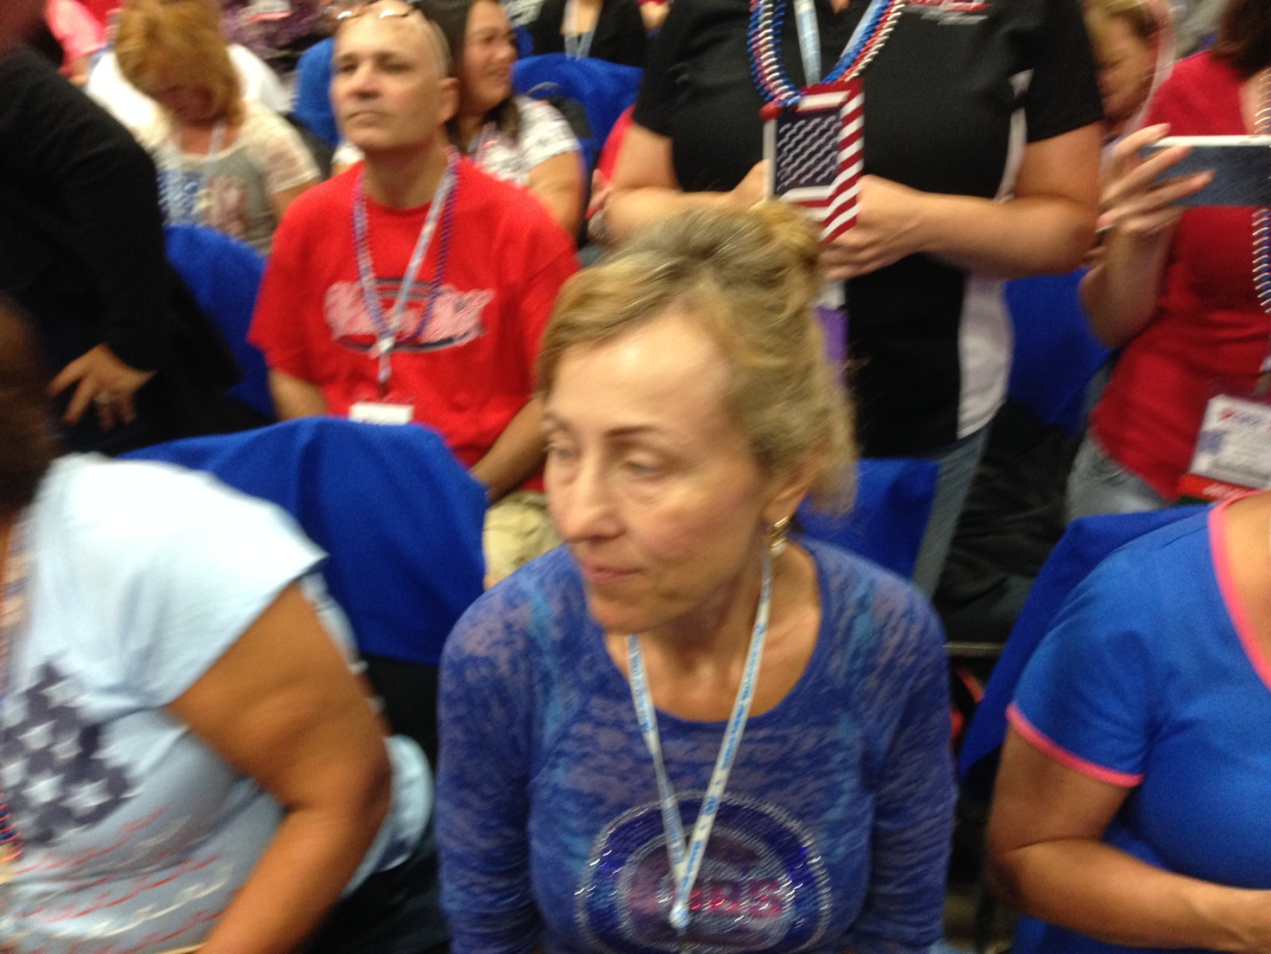

The work of the delegates was physically taxing. Stella is representative of the delegates showing fatigue and an indomitable will to persevere. We were all starting to feel the 12 hour days and what sometimes seemed to be endless debate over arcane points that were not related to our particular issues.

**HOORAY A CLEAN SWEEP! ALL THREE OF OUR NEW BUSINESS ITEMS WERE PASSED.**

### [New Business Item 81](http://ra.nea.org/business-item/2016-nbi-081/)

### Adopted As Modified

NEA, working with the NEA Contingent Faculty Caucus and other contingent Higher Education activists, will advocate for equal access to retirement benefits by investigating best practices and developing strategies for providing faculty and professional staff employed in part-time positions with appropriately prorated retirement benefits.

**These two ladies were the driving force behind the Legislative Amendments**

**YOGA 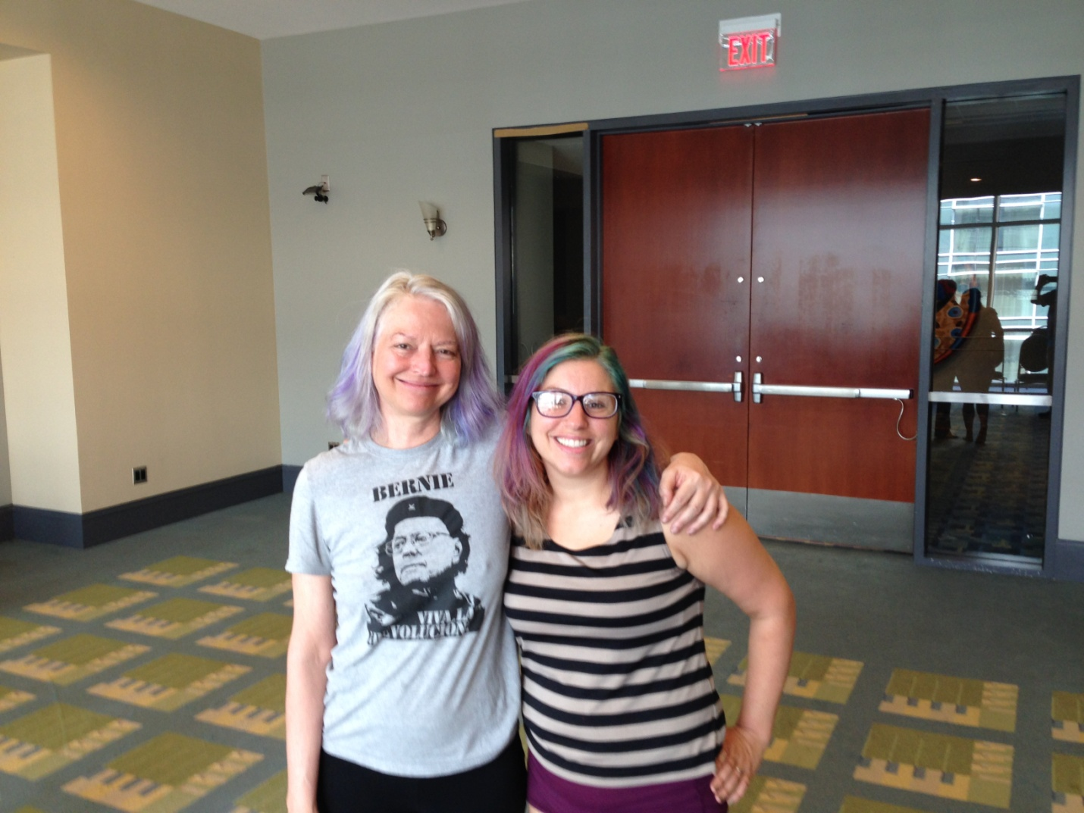**

We completed new business today & so tomorrow at 9:15 am we will have a free restorative yoga class taught by certified Iyengar instructor. Please feel free to spread the word & bring a friend.  Its a good idea to bring a towel from your room or blanket because the convention center floor is not ideal to lay on.

We will meet in room 304.  It is on the same floor where the floor where the ballroom for human rights dinner took place.  Please feel free to text or email if you have any questions.

Chris Cruz-Boone

Secretary, CFC NEA [ccruzboone@gmail.com](mailto:ccruzboone@gmail.com) 661-204-8643

Judy Olson [Jolson99@sbcglobal.net](mailto:Jolson99@sbcglobal.net) 323-491-5326

In my opinion this RA of 2016 was a great success for Contingent Faculty. There are three areas that I feel we made the most progress. One, the work of the Contingent Faculty Caucus was to bring our existence and unique issues into the mainstream of the NEA. Two, the election of Loretta Ragsdell, a fellow Adjunct Instructor is extremely encouraging. Third, is the new emphasis on ending the GPO/WEP. (See New Business Items 13, 14, 15.)

### [New Business Item 10](http://ra.nea.org/business-item/2016-nbi-010/)

### Adopted

Working with the NEA-Retired Executive Council, the Center for Advocacy will plan and hold a national retirement security advocacy day in the spring of 2017. The purpose of this one day on Capitol Hill would be to focus on effective and beneficial Social Security Reform including the repeal of the Government Pension Offset (GPO) and the Windfall Elimination Provision (WEP), opposition to mandatory coverage of Social Security and opposition to privatization. Activities for this day would include visits to Congressional offices and a national call-in effort. Participants would include (but not be limited to) NEA Board members representing NEA-Retired, NEA-Retired Executive Council members, state-retired presidents/chairs and the NEA-Retired Rapid Response Team.

### [New Business Item 14](http://ra.nea.org/business-item/2016-nbi-014/)

### Adopted

The NEA shall request that our recommended (primary) candidate, Hillary Clinton, write a letter directed to NEA members stating that one of her priorities as president will be to work to repeal the GPO/WEP (Government Pension Offset/Windfall Elimination Provision).

### [New Business Item 15](http://ra.nea.org/business-item/2016-nbi-015/)

### Adopted

The NEA will present to the 2017 Representative Assembly (RA) an electronic executive summary of the NEA’s organizing efforts to save/strengthen Social Security and repeal of the offset provisions of Social Security–the Government Provision Offset (GPO) and the Windfall Elimination Provision (WEP). Included in the presentation will be descriptions about what is being done now, will be ongoing, and proposed for the future.

**As the Donald says this is HUGH. Loretta Ragsdell first Adjunct Faculty elected to the NEA Board of Directors.**

**Loretta spoke to the Illinois Caucus after her win in the election runoff where she was a favorite daughter from Illinois. She promised to continue as a strong advocate for Adjuncts as our representative on the NEA Board of Directors.**

Delegates to the 2016

NEA Representative Assembly will elect

10

At large representatives to the NEA Board

of Directors as follows:

•

One (1)

administrator.

•

Four (4)

classroom teachers in higher education.

•

Five (5)

Active members employed in education support professional positions

|  |  |  |  |
| --- | --- | --- | --- |
| **At-Large Higher Education – 4 positions (3-year term)** | | | |
|  |  | **Votes** | **Percentage** |
| **Elected** | **DeWayne Sheaffer** | **3,467** | **85.37%** |
| **Elected** | **Loretta A. Ragsdell** | **3,385** | **83.35%** |
| **Elected** | **Elizabeth K. Davenport** | **3,248** | **79.98%** |
| **Elected** | **J. Philippe Abraham** | **3,184** | **78.40%** |
|  | Barbara Cady | 2,960 | 72.89% |

**Campus Equity Week: Contingent faculty take their case to Congress**

*by Mary Ellen Flannery*

**Take Action ›**

Support the Adjunct Faculty Loan Fairness Act of 2015. [Click here ›](https://actionnetwork.org/forms/support-the-adjunct-faculty-loan-fairness-act-of-2015)

Inside a Capitol Hill hearing room on Monday, adjunct professor Loretta Ragsdell kicked off [Campus Equity Week 2015](http://www.nea.org/home/campus-equity-week.html) with a grim story about grocery shopping on an adjunct salary. It involved a colleague who abandoned her shopping cart when she discovered a student behind the cash register.

“She was ashamed to show her [food-stamp] card to her student,” said Ragsdell.

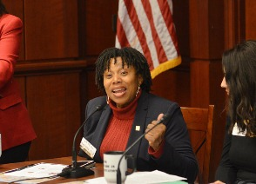

Loretta Ragsdell, adjunct professor. Photo by Patrick G. Ryan

During this week, adjunct or contingent faculty are casting aside their shame to tell their stories — on social media, in blogs, and especially on Capitol Hill, where they hope lawmakers and policymakers will take notice of the non-tenured faculty workforce, which now constitutes about 75 percent of all faculty in the U.S.

After all, pointed out Judy Olson, chair of NEA’s Contingent Faculty Caucus, “Faculty working conditions are student learning conditions.”

The panel presentation on Monday, which was organized by the nonprofit advocacy group New Faculty Majority and featured several NEA Higher Ed members, drew attention to several federal policy issues, including barriers to adjunct faculty fairly obtaining unemployment benefits and federal public service loan forgiveness.

The event kicked off with a video greeting from Sen. Dick Durbin (D-IL), whose Adjunct Faculty Fairness Act would make adjunct faculty eligible for public service loan forgiveness — just like full-time faculty. “You shouldn’t be excluded from loan forgiveness. Adjunct faculty are public servants too,” Durbin told them. “Reach out to Congress and ask them to support this bill.”

The objective reality in relation to non-tenured track instructors is that we are 70% of the teaching faculty in higher education. The dichotomy between our importance in teaching and our compensation in comparison with the Tenured Track Faculty and ever expanding Administrations is undeniable. This situation is becoming more untenable every day. Change will come because it must. Join us as we work to effectuate this change. Be part of this positive movement to improve Adjuncts working lives. Participate in your union and change our world for the better. Become the change that you wish for.

.

***Hang on fellow CODAA members it's going to be an exciting ride!***

