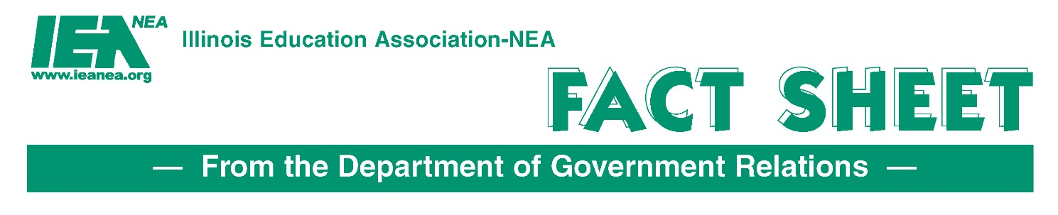
SURS Adjunct Calculation
SB 1235 (Sen. Martwick/Rep. Kifowit)
IEA Initiative
The Issue: Currently, adjunct professors in Illinois are not being credited with the correct number of months/years of service credit due to the way the State Universities Retirement System’s (SURS) article of the pension code defines a month of service credit.
The pension code currently does not consider that adjuncts normally never start on the 1st day of the month. These employees are often hired to provide services with little notice and be prepared to teach almost immediately. This often excludes these adjuncts from receiving service credit for August, December, January and May. This exclusion is based on the definition of a month which requires at least 15 days of employment. However, these adjuncts meet the standard for services rendered on a continuous basis.
What causes adjuncts to be negatively impacted and lose months/years of service credit?
• Adjuncts may teach a 12-week, 10-week, or even an 8-week accelerated course but must deliver the same material as a 16-week course since they are all accredited courses simply taught in a shorter and compressed timeframe. These types of services do not allow for an adjunct to receive full creditable service even though they are providing a full semester of work in that timeframe.
• Adjunct faculty must be prepared and present the course syllabi on the first day of classes. This prep-time requires work and service that is not recognized by the employer when they are offered a contractual position. This ultimately reduces the months of service an adjunct can earn simply because of their contractual start time with SURS covered employer.
• Adjunct faculty must hold office hours for students even when those hours may not be counted as SURS covered work.
Rationale for Support: SB 1235 ensures that members will receive full-service credit for work performed in any month a member makes their required SURS pension contribution on earnings earned in a month. The legislation only applies to participants in SURS on or after September 1, 2024.
This legislation recognizes that all services rendered and earned earnings will be fully credited to the SURS participants.

